Project Design Phase-II
Data Flow Diagram & User Stories
Date | -08 March 2026
Team ID
Project Name | AI Based Exam Anxiety Detector
Maximum Marks | 4 Marks

Data Flow Diagrams:
A Data Flow Diagram (DFD) is a traditional visual representation of the information flows within a system. A neat and clear DFD can depict the right amount of the system requirement graphically. It shows how data enters and leaves the system, what changes the information, and where data is stored.
Example: (Simplified)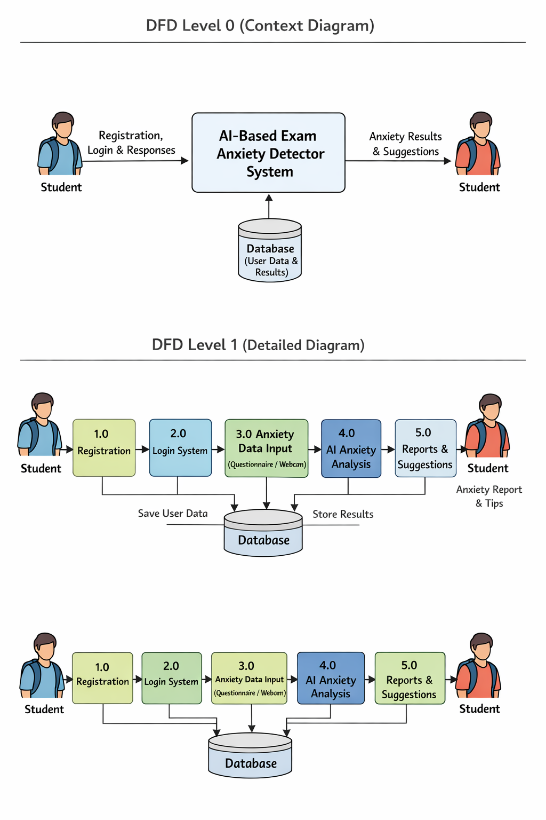
User Stories
Use the below template to list all the user stories for the product.
User Type | Functional  Requirement  (Epic) | User Story Number | User Story / Task | Acceptance criteria | Priority | Release
Student (Web/Mobile User) | Registration | USN-1 | As a student, I can register for the application using my email and password. | I can successfully create an account and access my dashboard. | High | Sprint-1
 | Registration | USN-2 | As a student, I receive a confirmation email after registration. | I can verify my account through email confirmation. | High | Sprint-1
 | Login | USN-3 | As a student, I can log into the system using my email and password. | I can access my personal dashboard after login. | High | Sprint-2
 | Anxiety Detection | USN-4 | As a student, I can complete a questionnaire related to exam stress. | The system records my responses for analysis. | High | Sprint-2
 | AI Analysis | USN-5 | As a student, the AI analyzes my responses to detect anxiety level. | I receive an anxiety score and feedback. | High | Sprint-2
 | Report | USN-6 | As a student, I can view my anxiety report on the dashboard. | The system displays my stress level and suggestions. | High | Sprint-3
 | Recommendations | USN-7 | As a student, I receive tips and relaxation exercises to reduce exam stress. | I can view personalized suggestions and mental health tips. | Medium | Sprint-3
Administrator | System Management | USN-8 | As an administrator, I can monitor student usage and system performance. | Admin can view analytics and manage the platform. | Medium | Sprint-4

